* System Description
  + Our project, GoodMail, will perform similarly compared to gmail where we will have a webpage interface that requires login information. As a user, you will have the ability to manage your emails, including composing, receiving, categorizing, organizing, and writing a note. As an admin, you will have the ability to manage all the users and their information, such as adding a new user or removing an existing user, as well as managing the information in the database.
* Use case description
  + The main use cases would be
  + The sender composing an email, which includes its subject name, the recipient's name, the date, the message, and an optional attachment, that is received by the recipient.
  + The sender or recipient adding a selected email to a specified folder of emails.
  + The sender or recipient adding a note of their own message.
  + The emails are automatically saved to a certain cat
* Implementation details
  + We will use python as the backend language to connect to the database
  + We will use html to build our webpage interface.
  + We will utilize sql queries to practice inserting and retrieving data between the database and the interface

**UML Use Case Diagram**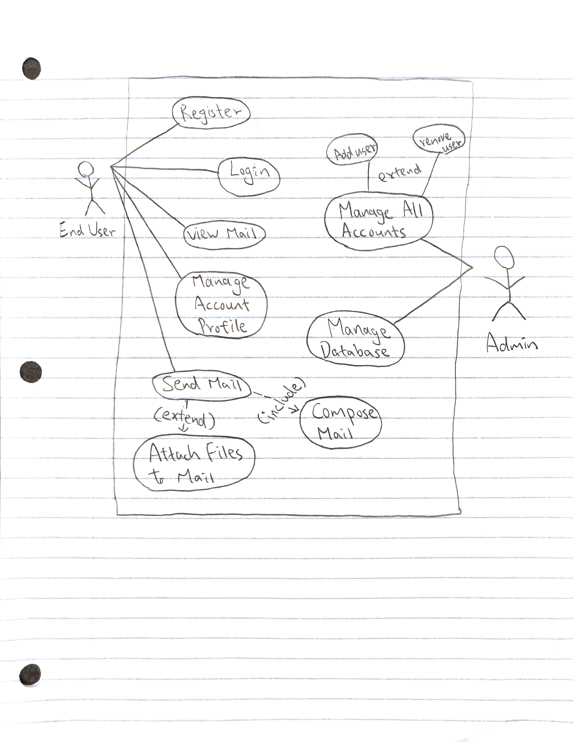

**ER Diagram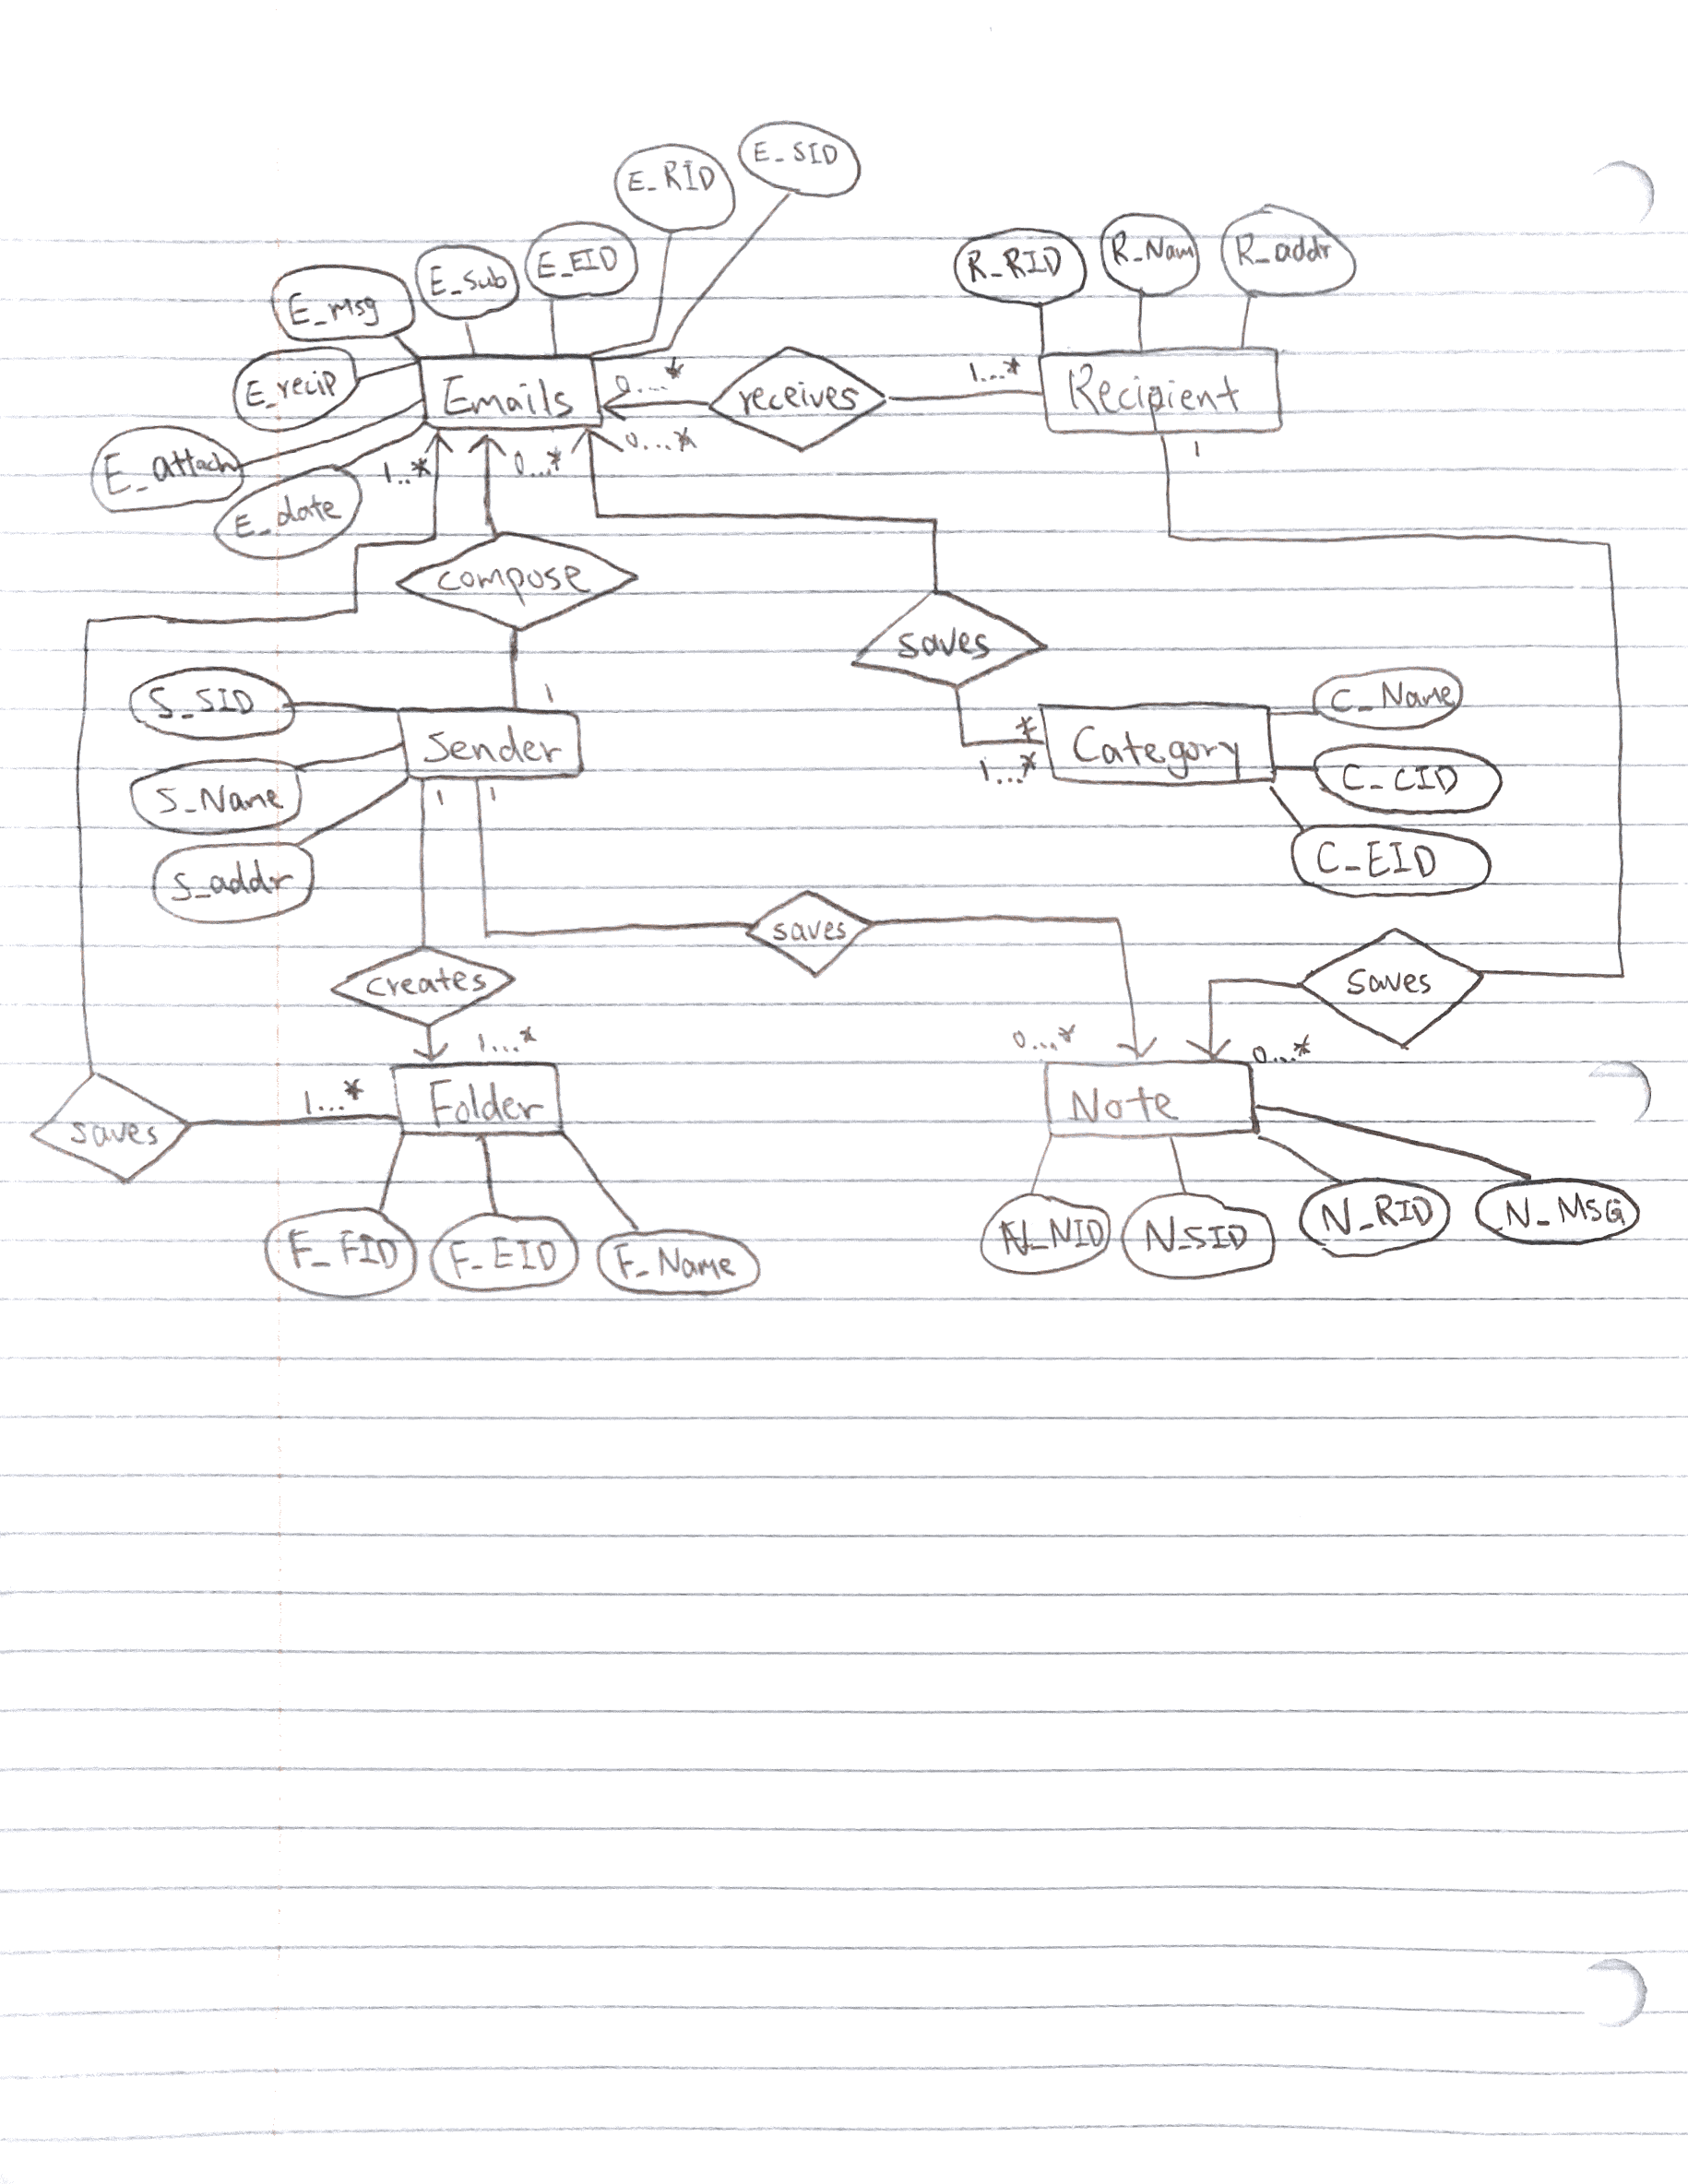Relation Schema**